­­­­Project Report-2018

**AUTOMATIC IRRIGATION SYSTEM**



**GUIDED BY** **DONE BY**

Ms S.BACKIA LAKSHMI B.E., M.PRABHAKARAN (154633)

P.T.LECTURER/COMPUTER, S.PANDIESWARAN (154631)

M.MAHESHWARAN (154624)

R.SUTHARSAN (154646)

M.KAVASKAR (154623)

C.THISAN (154649)

**TAMILNADU POLYTECHNIC COLLEGE** (**Autonomous**), **MADURAI-11**

**DEPARTMENT OF COMPUTER ENGINEERING**

In Partial fulfilment of the requirements for the award of Diploma in Computer Engineering of the Directorate of Technical Education,Chennai-13

Project Report-2018

**AUTOMATIC IRRIGATION SYSTEM**



**GUIDED BY** **DONE BY**

Ms S.BACKIA LAKSHMI B.E., M.PRABHAKARAN (154633)

P.T.LECTURER/COMPUTER, S.PANDIESWARAN (154631)

M.MAHESHWARAN (154624)

R.SUTHARSAN (154646)

M.KAVASKAR (154623)

C.THISAN (154649)

**TAMILNADU POLYTECHNIC COLLEGE** (**Autonomous**), **MADURAI-11**

**DEPARTMENT OF COMPUTER ENGINEERING**

In Partial fulfilment of the requirements for the award of Diploma in Computer Engineering of the Directorate of Technical Education,Chennai-13

**BONAFIDE CERTIFICATE**

Certificate that this project report “AUTOMATIC IRRIGATION SYSTEM” is the bonafide Work of_______________________________________________________

Who carried out the project under my supervisor.

**SIGNATURE OF THE PROJECT SIGNATURE OF THE**

**GUIDE HEAD OF DEPARTMENT**

Ms.S. BACKIALAKSHMI,B.E., Mrs.T.HEMA CHITHRA,M.E,

Part-time Lecture, HOD(i/c)

Department Of Computer Engineering, Department Of Computer Engineering,

Madurai-11 Madurai-11

Submitted for Board Examination held on ___________________________________

**INTERNAL EXAMIER EXTERNAL EXAMIER**

**ABSTRACT**

**ABSTRACT**

Automatic irrigation system is a simple yet effective ways of sensing soil moisture content. In the domain of farming, utilization of appropriate means of irrigation is significant. The benefit of employing these techniques is to decrease human interference and still make certain appropriate irrigation. The main aim of this robot is prevent moisture stress in the plant irrigation. Drip irrigation saves requirement of water because only the plant. Still no one can develop the automatic irrigation robot for sensing the moisture from the soil. But we are developed the robot for this moisture stress problem

**CONTENT**

**CONTENTS**

**CHAPTER TITLE PAGE NO**

1 **INTRODUCTION**  2

2 **SYSTEM ANALYSIS**

2.1 EXISTING SYSTEM 4

2.2 PROPOSED SYSTEM 5

3 **SYSTEM SPECIFICATION**

3.1 REQUIRMENTS 7

4 **BLOCK DIAGRAM** 9

5  **MODULE DESCRIPTION** 10

6 **SAMPLE CODING** 12

7  **SCREENSHOTS** 15

8  **FUTURE ENHANCEMENT** 19

9  **CONCLUSION**  21

10 **REFERENCES** 23

**INTRODUCTION**

**-1-**

**INTRODUCTION**

Continuous increasing demand of food requires the control in highly specialized greenhouse vegetable rapid improvement in food production technology. In a production and it is a simple, precise method for country like India, where the economy is mainly based on irrigation. It also helps in time saving, removal of human agriculture and the climatic conditions are isotropic, still error in adjusting available soil moisture levels and to we are not able to make full use of agricultural resources. Maximize their net profits. The main reason is the lack of rains & scarcity of land Irrigation is the artificial application of water to the soil reservoir water. The continuous extraction of water from usually for assisting in growing crops. Another shortfalls, but also to protect plants against frost. Very important reason of this is due to unplanned use of Types of Irrigation water due to which a significant amount of water goes to surface irrigation waste. Localized irrigation in modern drip irrigation systems. The plants drip by drip due to which a large quantity of water is saved. Lower leaves and stem of the plants. The entire soil this process sometimes consumes more water or surface is saturated and often stays wet long after irrigation sometimes the water reaches late due to which crops is completed. Such condition promotes infections by leaf get dried.Slowed growth rate, lighter a type of modern irrigation technique that slowly applies weight fruit follows slight water deficiency. This problem small amounts of water to part of plant root zone. Water is can be perfectly rectified if we use automatic micro supplied frequently, often daily to maintain favorable soil controller based drip irrigation system in which the moisture condition and prevent moisture stress in the plant irrigation will take place only when there will be acute with proper use of water resources. Drip irrigation saves requirement of water because only the plant.

**-2-**

**SYSTEM ANALYSIS**

**-3-**

**EXISTING SYSTEM**

In drip irrigation method the existing system is used by farming. The drip irrigation is mainly used in gardens in houses and other farms that which are used to cultivate carrot, beetroot, potato, and etc. That the human beings are used to maintain the drip irrigation most of the olden days. Because nowadays the drip irrigation is used as manmade irrigation system. So the humans may be work most of the day to cultivate there food products as in the good quality. So the irrigation is also used decrease the human stress in agriculture field. And also the irrigation in start-up days it must be maintained by human beings.

**DISADVANTAGE:-**

* If the water is not properly filtered and the equipment not properly maintained, it can result in clogging or bio clogging.
* This kind of irrigation method is mostly maintained by human begins for 24/7 hours.

**-4-**

**PROPOSED SYSTEM**

A complete block diagram of proposed automated irrigation system is illustrated in Fig. 1. The area of paddy field usually may cover up several hundreds of hectares; to cover the whole area we need to place different sensors in the paddy field. The sensors will always sense the water level of the field and will send a message to the user’s cell phone to inform the condition of irrigation through the DTMF (Dual Tone Multi Frequency) signalling. Farmer will control the motor sending assigned code to the microcontroller. A Photo Voltaic (PV) cell is the only source of energy to drive this proposed system. The energy will be stored in the DC Battery through power supply. The sensors, microcontroller and cell phone interface are driven by DC power. However, pump is driven by AC power; inverter is used to convert DC to AC power, and AC power interface ensures the proper AC power supply to the pump

**ADVANTAGE:-**

* This kind of automatic irrigation is used to improve the agriculture in future periods.
* This is also used to reduce the human stress.
* This is a man made robot. So, the time period to cultivation is also lesser than before.

**-5-**

**SYSTEM SPECIFICATION**

**-6-**

**3.1 REQUIREMENTS**

* ARDUNIO UNO R3 BOARD
* SOIL SENSOR
* PUMP MOTOR 5V
* MALE & FEMALE CONNECTOR
* RESISTOR & 2N2222 NPN TRANSISTOR
* LED BULB
* POWER ADAPTER
* ARDUNIO 1.8**.**5 (**software used**)

**-7-**

**ARCHITECTURE DIAGRAM**

**-8-**

**ARCHITECTURE DIAGRAM**

**POWER SUPPLY**

**ARDUNIO**

**UNO R3**

**SOIL**

**SENSOR**

**RESISTOR**

**MOTOR PUMP 5V**

**-9-**

**MODULE DESCRIPTION**

**-10-**

**MODULE DESCRIPTION**

**ASSEMBLE THE ARDUINO KIT:**

* Assemble of the arduino kit and other all circuits are main part of our project.
* In this module we will connect all the necessary connection into the arduino kit from the soil moisture sensor to the pump irrigation kit and other digital outputs.
* Here we will test the kit with the sample program we created to check the arduino kit current running connections.

**SENSING SOIL MOISTURE:**

* Once the program activates the arduino kit then it checks the soil current condition
* testing the soil moisture level at the soil is the main concept of our project.
* While testing the moisture level it calculates the percentage of moisturization of soil.
* If the percentage is lower than we instructed in the program then the soil moisture sensor take notes of the reading and sent it to the program.

**AUTOMATIC IRRIGATION:**

* Once the program gets the input as the percentage of the moisture condition of the soil it will process it.
* If it finds out that the moisture level is below the perfect level for given condition of soil then it signals the arduino kit.
* Then the kit will run the motor installed into it then pass the water form the source to the soil which is selected for the test to improve the current moisture level of the soil.

**-11-**

**SAMPLE CODING**

**-12-**

**SAMPLE CODE**

const int VAL_PROBE = 0; //Analog pin 0

const int MOISTURE_LEVEL = 250; // the value after the LED goes on

void setup()

{

pinMode(13, OUTPUT);

pinMode(7, OUTPUT);

}

void LedState(int state)

{

digitalWrite(13,state);

}

void loop()

{

int moisture = analogRead(VAL_PROBE);

**-13-**

Serial.print(“Moisture = “);

Serial.println(moisture);

if(moisture > MOISTURE_LEVEL)

{

LedState(HIGH);

}

else

{

LedState(LOW);

}

delay(500);

}

**-14-**

**SCREENSHOTS**

**-15-**

**SCREENSHOTS**

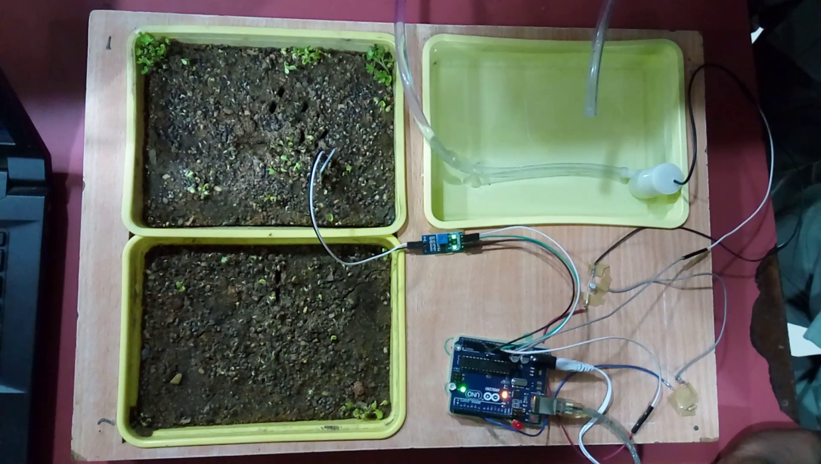

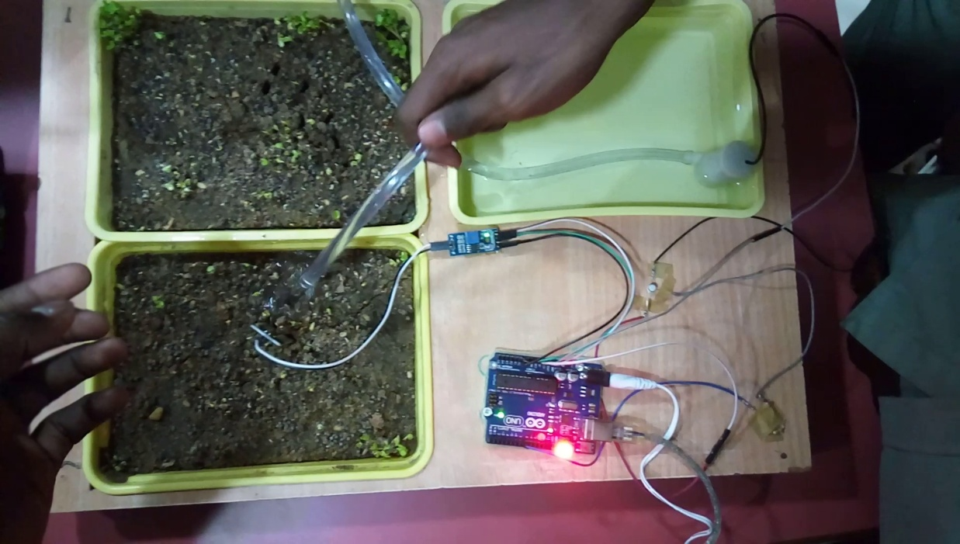

**-16-**

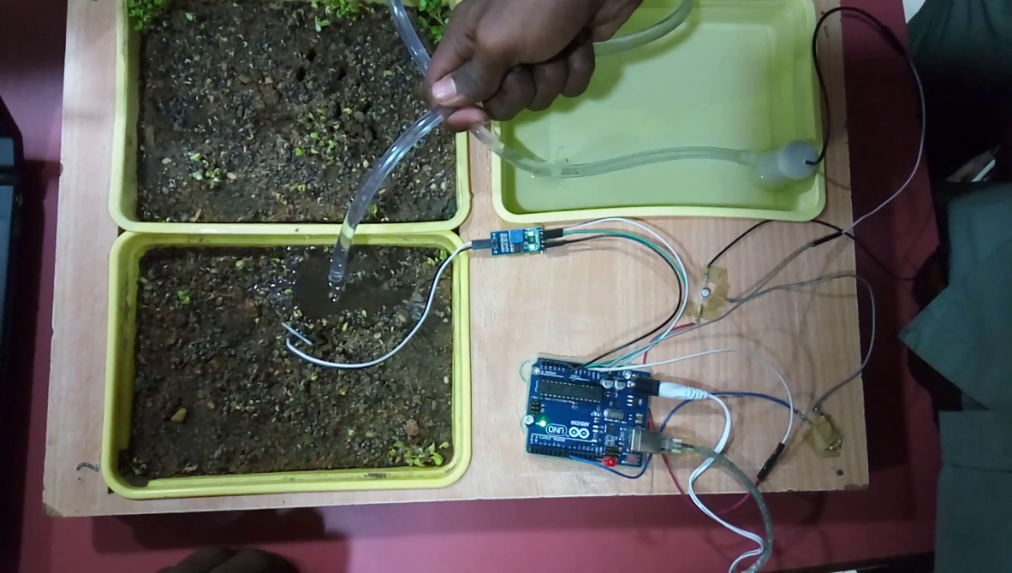

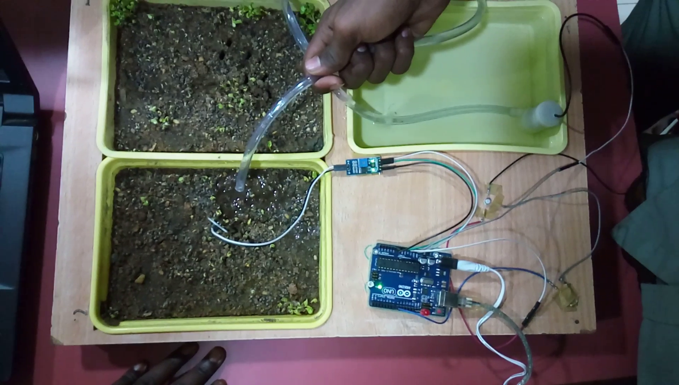

**-17-**

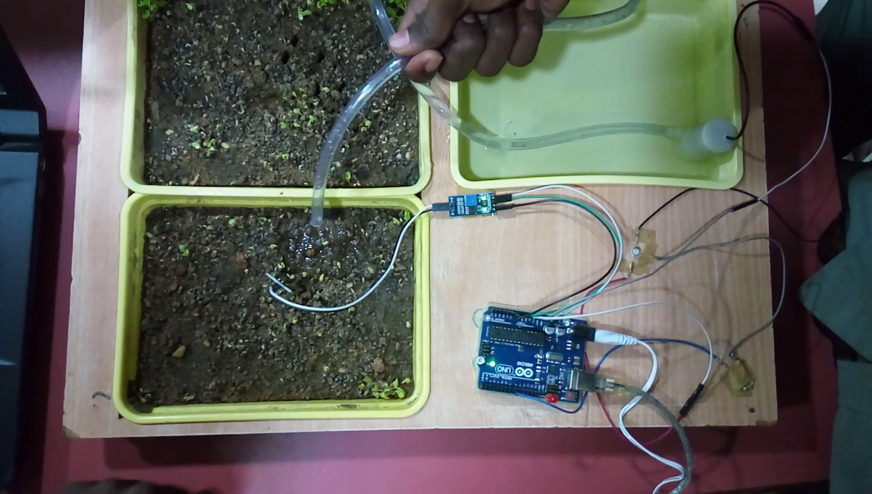

**-18-**

**FUTURE ENHANCEMENT**

**-19-**

**FUTURE ENHANCEMENT**

* Communication through Gsm module.
* Solar power and wireless sensor application.
* Can also be used in poly house

**-20-**

**CONCLUSION**

**-21-**

**CONCLUSION**

The primary applications for this project are for farmers and gardeners who do not have enough time to water their Crops/plants. It also covers those farmers who are wasteful of water during irrigation. The project can be extended to greenhouses where manual supervision is far and few in between. The principle can be extended to create fully automated gardens and farmlands. Combined with the principle of rain water harvesting, it could lead to huge water savings if applied in the right manner. In agricultural lands with severe shortage of rainfall, this model can be successfully applied to achieve great results with most types of soil.

**-22-**

**REFERENCES**

**-23-**

**REFERENCES**

[www.electronicshub.org/automatic-plant-irrigation-system/](http://www.electronicshub.org/automatic-plant-irrigation-system/)

[www.youtube.com/watch?v=NcUoqhwSXXo](http://www.youtube.com/watch?v=NcUoqhwSXXo)

[www.instructables.com/id/Automatic-Irrigation-System-for-Indoor-Gardening-U/](http://www.instructables.com/id/Automatic-Irrigation-System-for-Indoor-Gardening-U/)

[www.electroschematics.com/6519/simple-soil-moisture-sensor-ardunio-project](http://www.electroschematics.com/6519/simple-soil-moisture-sensor-ardunio-project)

[www.electronicsforu.com/electronics-projects/hardware-diy/automatic-plant-watering-system](http://www.electronicsforu.com/electronics-projects/hardware-diy/automatic-plant-watering-system)

**-24-**